Factory Method Pattern
# Source: AI Source: Provided by: [Data Path: Persons Table -> ID Column: 1, Name_En Column: Motasem Essam] -> From: [ChatGPT] on [1/23/2026]
The Factory Method Pattern defines an interface for creating an object, but lets subclasses decide which class to instantiate.
👉 Think of it like a restaurant kitchen: the menu (interface) defines what can be ordered, but the chef (subclass) decides exactly how to prepare it.

🔑 Key Points
# Source: AI Source: Provided by: [Data Path: Persons Table -> ID Column: 1, Name_En Column: Motasem Essam] -> From: [ChatGPT] on [1/23/2026]
• Separates object creation from usage
• Client depends on abstract types, not concrete classes
• Promotes flexibility, extensibility, and maintainability

❌ Bad Example
# Source: AI Source: Provided by: [Data Path: Persons Table -> ID Column: 1, Name_En Column: Motasem Essam] -> From: [ChatGPT] on [1/23/2026]
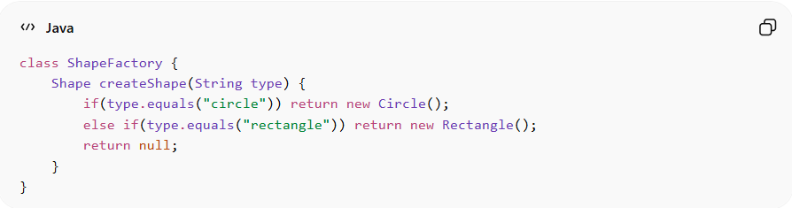
class ShapeFactory {
Shape createShape(String type) {
if(type.equals("circle")) return new Circle();
else if(type.equals("rectangle")) return new Rectangle();
return null;
}
}
Problems:
• Violates Open/Closed Principle – adding a new shape requires modifying the factory
• Conditional logic can grow complex and error-prone

✅ Good Example
# Source: AI Source: Provided by: [Data Path: Persons Table -> ID Column: 1, Name_En Column: Motasem Essam] -> From: [ChatGPT] on [1/23/2026]
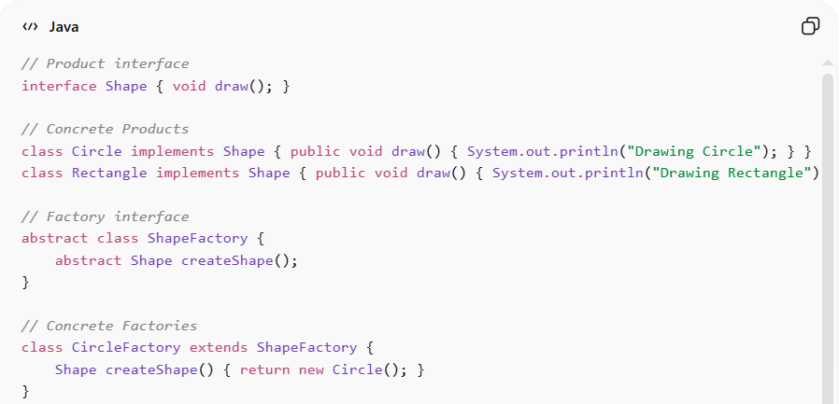
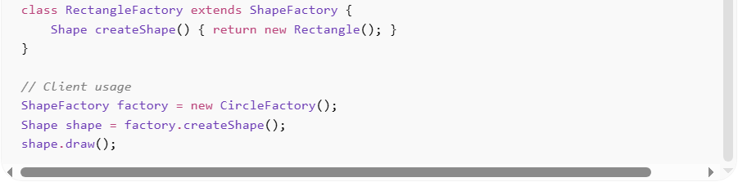
// Product interface
interface Shape { void draw(); }

// Concrete Products
class Circle implements Shape { public void draw() { System.out.println("Drawing Circle"); } }
class Rectangle implements Shape { public void draw() { System.out.println("Drawing Rectangle"); } }

// Factory interface
abstract class ShapeFactory {
abstract Shape createShape();
}

// Concrete Factories
class CircleFactory extends ShapeFactory {
Shape createShape() { return new Circle(); }
}

class RectangleFactory extends ShapeFactory {
Shape createShape() { return new Rectangle(); }
}

// Client usage
ShapeFactory factory = new CircleFactory();
Shape shape = factory.createShape();
shape.draw();
Benefits:
• Adds new shapes without modifying existing code
• Client code depends only on abstract types
• Promotes extensibility and maintainability

⚡ Advantages
# Source: AI Source: Provided by: [Data Path: Persons Table -> ID Column: 1, Name_En Column: Motasem Essam] -> From: [ChatGPT] on [1/23/2026]
• Decouples object creation from client code
• Follows Open/Closed Principle – easy to extend
• Supports polymorphic behavior

⚠️ Disadvantages
# Source: AI Source: Provided by: [Data Path: Persons Table -> ID Column: 1, Name_En Column: Motasem Essam] -> From: [ChatGPT] on [1/23/2026]
• Can introduce many small classes (one factory per product)
• Slightly more complex structure
• Client must know which factory to use

🛠️ Use Cases
# Source: AI Source: Provided by: [Data Path: Persons Table -> ID Column: 1, Name_En Column: Motasem Essam] -> From: [ChatGPT] on [1/23/2026]
• GUI frameworks – creating buttons or components for different platforms
• Document or report generation – different formats (PDF, HTML, Excel)
• Game development – spawning different enemy types or weapons
• Any system requiring flexible object instantiation without binding to concrete classes

